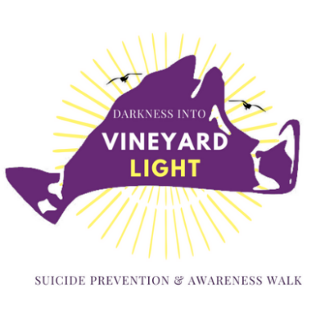

- PLATINUM $1,500 +
- Logo on all event marketing materials, including print and online materials
- Sponsor Recognition in DVL Walk press release
- Logo on event registration website with link to sponsor website
- Sponsor Recognition in email blasts
- Recognition on DVL walk sponsor banner
- Logo on back of event t-shirt
- Recognition via social media announcements
- SILVER $500+
- Sponsor Recognition in email blasts
- Recognition on DVL Walk sponsor banner
- Logo on back of event t-shirt
- Recognition via social media announcements

- BRONZE $250+
- Logo on back of event t-shirt
- Recognition via social media announcements
- GOLD $1,000+
- Recognition via social media announcements
- Sponsor Recognition in email blasts
- Recognition on DVL Walk sponsor banner
- Logo on back of event t-shirt
- Logo on event registration website with link to sponsor website

SPONSORSHIP REGISTRATION INFORMATION:

Contact Person_____________________________ Title ________________________________________

Company _______________________________________________________________________________

Address ________________________________________________________________________________

City__________________________________________________State_________Zip _________________

Telephone_____________________________________ Fax __________________________________

Email Address ________________________________________________

Please make checks payable to Martha’s Vineyard Youth Task Force with DVL in the memo field. The deadline for sponsorship is Monday September 6, 2021.

Donations may be sent to: DVL c/o Maria Ventura P.O. Box 872 Edgartown, MA 02539

